**PROJECT REPORT**

**On**

**DOCTOR APPOINTMENT SYSTEM**

*Submitted in partial fulfilment of* DBMS Laboratory with Mini-Project (17CSL58)

**Fifth Semester of the Degree of Bachelor of Engineering**

in

**COMPUTER SCIENCE AND ENGINEERING of**

**Visvesvaraya Technological University (VTU), Belgaum**

**during the year 2019-20**



**Carried out by**

**VASUDEVARAJU.B. K**

**1SB17CS093**

**PRASANNA R**

**1SB17CS063**

Under the Guidance of

**Dr. RENUKADEVI S**

Associate Professor

Dept. of Computer Science Engineering,

Sri Sairam College of Engineering, Bangalore

**Department of Computer Science and Engineering**

**SRI SAIRAM COLLEGE OF ENGINEERING**

**Anekal, Bengaluru - 562106**

**SRI SAIRAM COLLEGE OF ENGINEERING**

**Anekal, Bengaluru - 562106**



**Department of Computer Science and Engineering**

**CERTIFICATE**

Certified that project work entitled “**DOCTOR APPOINTMENT SYSTEM**” is Bonafide work carried out by

**VASUDEVARAJU.B. K**

**(1SB17CS093)**

**PRASANNA R**

**(1SB17CS063)**

In partial fulfillment for the award of the Bachelor of Engineering in Computer Science and Engineering of the Visvesvaraya Technological University, Belgaum during the year 2019-20. It is certified that all corrections/suggestions indicated for the internal assessment have been incorporated in the report deposited in the department library. The project has been approved as it satisfies the academic requirements in respect of the project work prescribed for Bachelor of Engineering Degree.

|  |  |
| --- | --- |
| Signature of the Guide | Signature of the HOD |
| Dr. RENUKADEVI S | **Dr. G MANJULA** |
| Assoc. Prof., CSE Dept. | **Professor & HOD, CSE Dept.,** |
| SSCE. | **SSCE.** |
| External Viva |  |

Name of the Examiners: 1. ____________________________

2.___________________________



**DECLARATION**

We, the students of the fifth semester of Computer Science and Engineering, Sri Sairam College of Engineering, Anekal, declare that the work entitled **“DOCTOR APPOINTMENT SYSTEM”** has been successfully completed under the guidance of **Dr. RENUKADEVI S**, Associate Professor Computer Science and Engineering Department, Sri Sairam College of Engineering, Anekal. This dissertation work is submitted to Visvesvaraya Technological University in partial fulfilment of the requirements for the award of Degree of Bachelor of Engineering in Computer Science during the academic year 2019 - 20120. Further, the matter embodied in the project report has not been submitted previously by anyone for the award of any degree or diploma to any university.

Place:

Date:

|  |  |  |
| --- | --- | --- |
| Team members: | |  |
| 1. | Vasudevaraju.B. K | (1SB17CS093) |
| 2. | Prasanna R | (1SB17CS063) |



**ACKNOWLEDGEMENT**

The knowledge and satisfaction that accompanies a successful completion of a project is hard to describe. Behind any successful project there are wise people guiding throughout. We thank them for guiding us, correcting our mistakes, and providing valuable feedback. We would consider it as our privilege to express our gratitude and respect to all those who guided and encouraged us in this project.

We extend our heartfelt gratitude to our chairman, **MJF. LN. LEO** **MUTHU** and also to our beloved principal, **DR. B. SHADAKSHARAPPA** for the success of this project.

We are grateful to **Dr. G MANJULA**, Prof., & Head of CSE Department, Sri Sairam College of Engineering, for providing support an encouragement.

We convey our sincerest regards to our Lab guide, **Dr. RENUKADEVI S,** Assoc. Prof., Dept. of CSE, SSCE, for providingguidance and encouragement at all times needed.





**ABSTRACT**

The **Doctor Appointment System** in PHP is a simple project developed using PHP, JavaScript, and CSS. The project contains an admin and user sides. The admin side manages all the management like managing doctors’ records, patient records and manage the appointment time, manage treatment facilities, and so on. The admin has an important role in the management of this online hospital management system.

For the user section, the users can either be a patient or a doctor. The user can log in as a doctor, check their appointment, patients, timings, and so on. Similarly, to log in as a patient, the user should have their login id and password for this hospital. If the patient doesn’t have them, they can first register as a new patient. The patient can check their appointment times, prescription records, treatment records, and so on.

This Doctor Appointment System is in PHP, JavaScript, and CSS. Talking about the features of this system, it contains the admin section and the user section. All the editing’s, updating, managing doctors, patients, appointments and editing treatment facilities are from the admin section. The main feature of this system is to provide the browser to get appointments from a doctor through the internet instead of going there and fixing an appointment. The design of this system is pretty simple so that the user won’t get any difficulties while working on it.



**CONTENTS**



|  |  |  |
| --- | --- | --- |
| SL NO | TITLE | PG NO |
| 1. | **Introduction** | **7** |
| 2. | **System Requirements** | **9** |
|  | 2.1 Hardware Requirements | **9** |
|  | 2.2 Software Requirements | **9** |
| 3. | **Schema Diagram** | **10** |
| 4. | **E-R Diagram** | **11** |
| 5. | **Implementation** | **12** |
| 6. | **Snapshots** | **20** |
| 7. | **Conclusion** | **26** |
| 8. | **Bibliography** | **27** |



1. **INTRODUCTION**

The **Doctor Appointment System** is a simple project developed using PHP, JavaScript, and CSS. The project contains an admin and user sides. The admin side manages all the management like managing doctors’ records, patient records and manage the appointment time, manage treatment facilities, and so on. The admin has an important role in the management of this online hospital management system. For the user section, the users can either be a patient or a doctor. The user can log in as a doctor, check their appointment, patients, timings, and so on. Similarly, to log in as a patient, the user should have their login id and password for this hospital. If the patient doesn’t have them, they can first register as a new patient. The patient can check their appointment times, prescription records, treatment records, and so on. This Doctor Appointment System is in PHP, JavaScript, and CSS. Talking about the features of this system, it contains the admin section and the user section. All the editing’s, updating, managing doctors, patients, appointments and editing treatment facilities are from the admin section. The main feature of this system is to provide the browser to get appointments from a doctor through the internet instead of going there and fixing an appointment. The design of this system is pretty simple so that the user won’t get any difficulties while working on it.

Booking an appointment online gives you a hassle-free experience. It is one of the simplest and popular pieces of today’s technology driven world. With the help of the increasing use of smartphones, tablets and other internet connected devices, the healthcare industry is being reshaped. Use of such technology has observed an uptick in the number of patients and the quality of the care taken. Patients can check the availability of the doctors and can schedule their appointments as per their convenience. [Booking an appointment](https://emanagehealth.com/) will help you to manage your time efficiently. You can also upload your medical reports on the database and can prevent misplacing of it. This also makes it easier for the doctors to know about their patients’ medical history by visiting their profile.

This will help you to book your appointment that comes with several other features such as:

* Paperless consultation or prescriptions.
* Electronic medical records which can be accessed anytime and anywhere.
* Automated communications to patients.
* Rescheduling appointments
* Find Doctors, Clinics, Medical collages, Hospitals in any locations.

Thus, booking an appointment benefits patients and doctors in a number of ways.

Since every coin has two phases, there are disadvantages as well. People who are not much familiar with the latest technologies or gadgets, they find it very difficult to book an appointment online and there prefer to go for the old conventional way for booking an appointment online.

Booking appointment with doctors is really benefits to working professionals. There is no need to do phone calls to the clinic for making an appoint which is done by some click now.

It helps to provide a better healthcare experience, by providing high satisfaction, continuing patient engagement remotely. From anywhere you can make an appointment in your busy schedule.



Usually calling repeatedly to clinics to get an appointment with a renowned doctor is the norm. But booking an appointment can make that process stress-free. You can see when the doctor is available and at which facility, around the clock, i.e. 24/7. You can [book an appointment](https://heallify.com/) at your convenience and make the time to plan out your visit well ahead. You can also be sure that your slot is confirmed.

Advantages of online doctor appointments system

* Easy time management for scheduling appointments
* Book doctor from at anyplace and anywhere from any portable devices like mobile, tablet etc.
* Helps to check doctor availability
* Reschedule appointments in case of change of mind
* Know the details of other doctors for consultation such as fee, reviews, services, availability etc.
* 24 hours booking services
* Secure and reliable booking services with patient reminder notification about appointments

The entire project has been developed keeping in view of the distributed client server computing technology, in mind. The specification has been normalized up to 3NF to eliminate all the anomalies that may arise due to the database transaction that are executed by the general users and the organizational administration. The user interfaces are browser specific to give distributed accessibility for the overall system. The internal database has been selected as MySQL database. The basic constructs of table spaces, clusters and indexes have been exploited to provide higher consistency and reliability for the data storage. The MySQL was a choice as it provides the constructs of high-level reliability and security. The total front end was dominated using the PHP technologies. At all proper levels high care was taken to check that the system manages the data consistency with proper business rules or validations. The database connectivity was planned using the latest “SQL Connection” technology provided by Microsoft Corporation. The authentication and authorization were crosschecked at all the relevant stages.





**2. SYSTEM REQUIREMENTS**



**2.1 HARDWARE REQUIREMENTS**

* Dual Core 2.8 GHz Processor and Above
* RAM 1GB and Above
* HDD 1 GB Hard Disk Space and Above

**2.2 SOFTWARE REQUIREMENTS**

* WINDOWS OS (XP / 2000 / 200 Server / 2003 Server/ 2007/ 8/ 10)
* HTML
* PHP
* WAMP / XAMPP Server
* MySQL



**3. SCHEMA DIAGRAM**

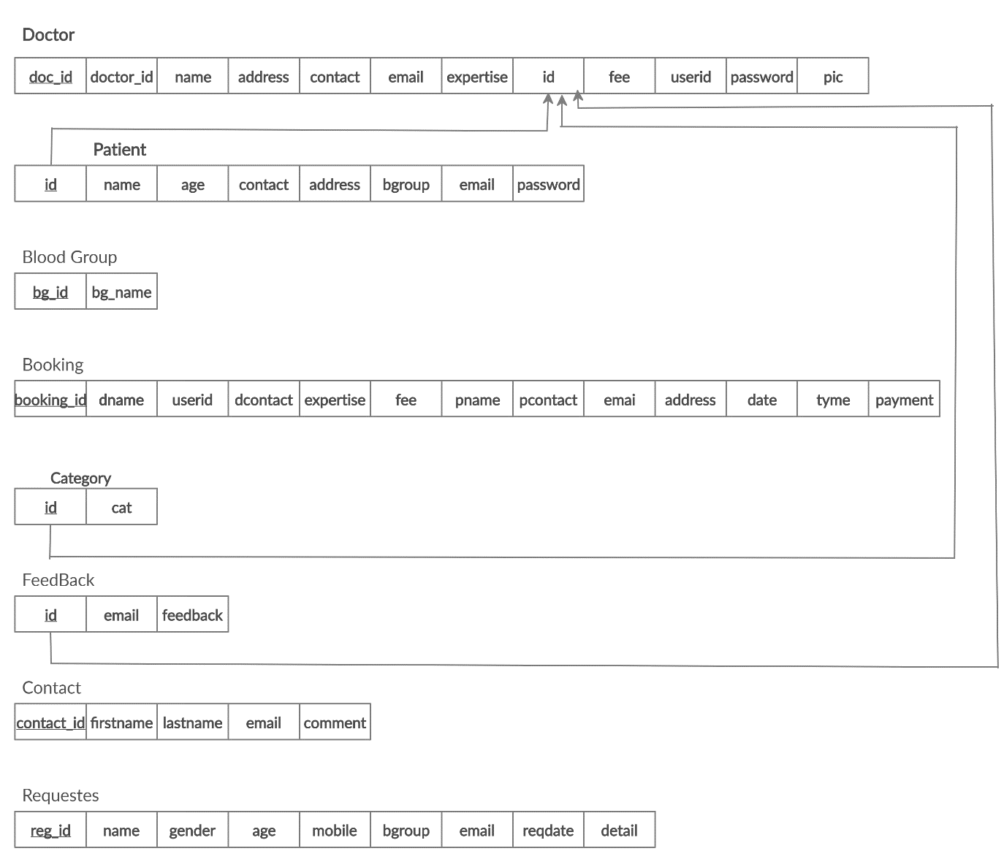

Fig. 3.1: Schema Diagram for Doctor Appointment System



**4. E-R DIAGRAM**

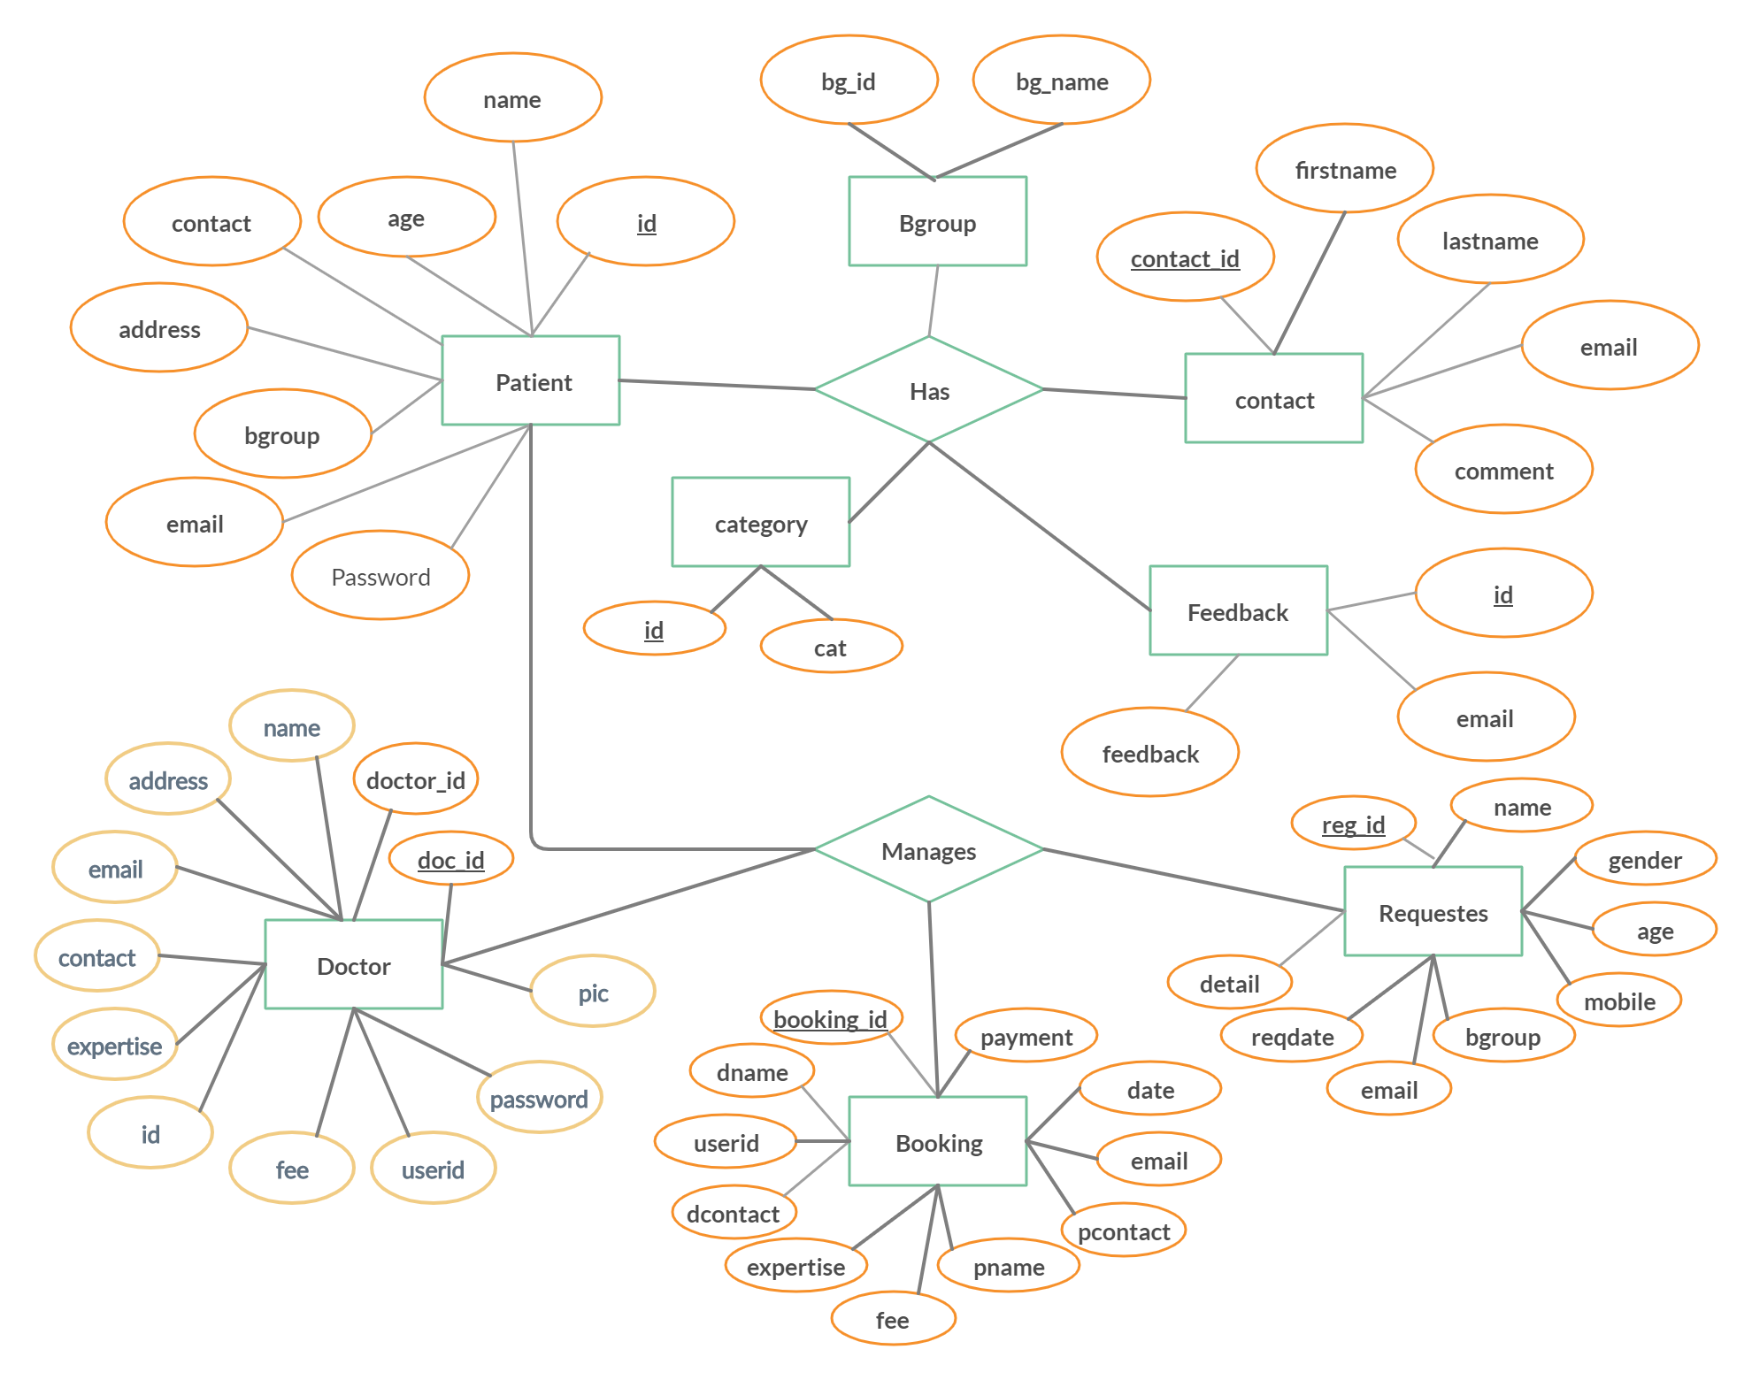

Fig. 4.1: Entity Relationship Diagram for Doctor Appointment System



1. **IMPLEMENTATION**

**Index.php**

<?php include('header.php'); ?>

<!-- this is for welcome -->

<div class="content">

<article>

<img src="img/welcome1.png" alt="welcome msg">

<p class="text-justify">Blood is universally recognized as the most precious element that sustains life. It saves innumerable lives across the world in a variety of conditions. The need for blood is great - on any given day, approximately 39,000 units of Red Blood Cells are needed. More than 29 million units of blood components are transfused every year. Donate Blood Despite the increase in the number of donors, blood remains in short supply during emergencies, mainly attributed to the lack of information and accessibility. We positively believe this tool can overcome most of these challenges by effectively connecting the blood donors with the blood recipients. </p>

</article>

</div><br>

<!-- nivo slider starts -->

<div class="col-md-12 sliderImg">

<img src="img/doctor5.jpg" alt="">

<img src="img/doctor3.jpg" alt="">

<img src="img/doctor4.jpg" alt="">

<img src="img/hstu8.jpg" alt="">

<img src="img/doctor3.jpg" alt="">

<img src="img/doctor4.jpg" alt="">

</div>

<!-- nivo slider ends -->

<!-- main Content -->

<div class="main_content">

<div class="col-md-8">

<article>

<h3 style="font-weight: bold;font-family:inherit;">

Finds Doctors from anywhere anytime!</h3><hr>

<p class="text-justify">Doctor Care Anywhere offers calm,reassuring support and advice and all the tools you <br> need to take care of you and your family’s health, whenever and wherever you need it.<br>

Simple, safe, secure support.</p>

</article>

 </div>

<div class="col-md-4">

<h3 class="text-center" style="font-weight:bold;font family:inherit;">Doctors Appoinment...?</h3><hr>

<ul class="text-justify">

A basic plan can help you make the most of your appointment whether you are starting with a new doctor or continuing with the doctor you’ve seen for years. This will make it easier for you and your doctor to cover everything you need to talk about.

</ul>

</div>

</div>

<?php include('footer.php'); ?>

</div><!-- containerFluid Ends -->

<script src="js/jquery-1.9.0.min.js"></script>

<script src="js/bootstrap.min.js"></script>

</body>

</html>

**book_appoinment.php**

<?php if(!isset($_SESSION)){

session_start();

}

?>

<?php include('header.php'); ?>

<?php include('uptomenu.php'); ?>

<!-- this is for donor registraton -->

<div class="recipient_reg" style="background-color:#272327;">

<h3 class="text-center" style="background-color:#272327;color: #fff;">Booking Appoinment</h3>

<div class="formstyle" style="float: right;padding:25px;border: 1px solid lightgrey;margin-right:415px; margin-bottom:30px;background-color: #101011;color:#d4530d;;">

<form enctype="multipart/form-data" method="post" class="text-center">

<div class="col-md-12">

<label>

Name: <input type="text" name="name" value="" placeholder="Full name" required>

</label><br><br>

<label>

Email: <input type="email" name="email" value="" placeholder="email" required>

</label><br><br>

<label>

Phone: <input type="number" name="contact" placeholder="contact no" required="required" pattern="[0-9]{10,11}" title="please enter only numbers between 10 to 11 for mobile no."/>

</label><br><br>

<label>

Address: <input type="text" name="address" value="" placeholder="address" required>

</label><br><br>

<label>

Category: <select name="expertise" required>

<option>-Select-</option>

<option>Medicine</option>

<option>Heart</option>

<option>Bone</option>

< <option>kedney</option>

<option>Cardiologist</option>

<option>Plastic Surgeon</option>

<option>General Physician</option>

</select>

</label><br><br>

<label>

Doctor: <select name="doctor" required>

<option>-Select-</option>

<option>Medicine Doctors</option>

<option>Heart Doctors</option>

<option>Bone Doctors</option>

<<option>kedney Doctors</option>

<option>Cardiologist Doctors</option>

<option>Plastic Surgeon Doctors</option>

<option>General Physician Doctors</option>

</select>

</label><br><br>

<label>

Date: <input type="date" name="date" placeholder="choose ur date" >

</label><br><br>



<button name="submit" type="submit" style="margin-left:60px;width: 85px;border-radius: 3px;">Check</button> <br>

</div> <!-- col-md-12 -->

</form>

</div>

</div>

<?php include('footer.php'); ?>

</div><!-- containerFluid Ends -->

<script src="js/bootstrap.min.js"></script>

<!-- validation and insertion -->

<?php

include('../config.php');

if(isset($_POST['submit'])){

$sql = "INSERT INTO patient (name,age,contact,address,bgroup,email, password)

VALUES ('" . $_POST["name"] ."','" . $_POST["age"] . "','" . $_POST["contact"] . "','" . $_POST["address"] . "','" . $_POST["bgroup"] . "', '" . $_POST["email"] . "','" . $_POST["password"] . "' )";

if ($conn->query($sql) === TRUE) {

echo "<script>location.replace('patient_success_msg.php');</script>";

} else {

echo "<script>alert('There was an Error')<script>" . $sql . "<br>" . $conn->error;

}

$conn->close();

}

?>

<!-- validation and insertion End-->

</body>

</html>



**myAppoinment.php**

<?php if(!isset($_SESSION)){

session_start();

} ?>

<?php include('header.php'); ?>

<!-- this is for donor registraton -->

<div class="dashboard" style="background-color:#fff;">

<h3 class="text-center" style="background-color:#272327;color: #fff;padding: 5px;">Today's Appoinment</h3>

</div>

<div class="all_user" style="margin-top:0px; margin-left: 40px;">

<?php

include('../config.php');

$sql = " SELECT * FROM booking WHERE userid='".$_SESSION["userid"]."'";

$result = mysqli_query($conn,$sql);

$count = mysqli_num_rows($result);

if($count>=1){

echo "<table border='1' align='center' cellpadding='32'>

<tr>

<th>Patient Name</th>

<th>Contact</th>

<th>E-mail</th>

<th>address</th>

<th>Date</th>

<th>Time</th>

</tr>";

while($row=mysqli_fetch_array($result)){

echo "<tr>";

echo "<td>".$row['pname']."</td>";

echo "<td>".$row['pcontact']."</td>";

echo "<td>".$row['email']."</td>";

echo "<td>".$row['address']."</td>";

echo "<td>".$row['dates']."</td>";

echo "<td>".$row['tyme']."</td>";

echo "</tr>";

}

echo "</table>";

}

else{

print "<p align='center'>Sorry, No match found for your search result..!!!</p>";

}

?>

</div>

<?php include('../footer.php'); ?>

</div><!-- containerFluid Ends -->

<script src="js/bootstrap.min.js"></script>

</body>

</html>

**patient_success_msg.php**

<?php include('header.php'); ?>

<!-- this is for donor registraton -->

<div class="login" style="background-color:#fff;">

<h1 class="text-center" style="background- color:#272327;color: #fff;">Congratulations....!!!</h1>

<p class="text-center">You have been registered!</p>

<div class="formstyle" style="float: right;padding:20px;border: 1px solid lightgrey;margin-right:415px; margin-bottom:30px;background-color:#f3f3f8;color:#141313;">

<form action="" method="post" class="text-center">

<label>

Email: <input type="email" name="email" placeholder="username" required>

</label><br><br>

<label>

Password: <input type="password" name="password" placeholder="password" required>

</label><br><br>

<button name="submit" type="submit" style="margin-left:36px;width: 85px;border-radius: 3px;">Login</button> <br>

<!-- Not a member?

<a href="donor_seeker_regi.php" title="create a account" target="" style="color:black;">&nbsp;Sign Up</a> <br> -->

<!-- login validation -->

<?php

include('config.php');

if(isset($_POST["submit"])){

$sql= "SELECT * FROM patient WHERE email= '" . $_POST["email"]."' AND password= '" . $_POST["password"]."'";

$result = $conn->query($sql);

if ($result->num_rows > 0) {

// $_SESSION["email"]= $_POST["email"];

// $_SESSION['userstatus']= "yes";

echo "<script>location.replace('patient/dashboard.php');</script>";

echo "u are supposed to redirect to ur profile";

} else {

echo "<span style='color:red;'>Please, check username and password</span>";

}

$conn->close();

}

?>

<!-- login validation End-->

</form> <br>&nbsp;&nbsp;&nbsp;

<br>

</div>

</div>

<?php include('footer.php'); ?>

</div><!-- containerFluid Ends -->

<script src="js/bootstrap.min.js"></script>

</body>

</html>

**view_booking.php**

<?php if(!isset($_SESSION)){

session_start();

}

?>

<?php include('header.php'); ?>

<?php include('uptomenu.php'); ?>

<!-- this is for donor registraton -->

<div class="dashboard" style="background-color:#fff;">

<h3 class="text-center" style="background-color:#272327;color: #fff;padding: 5px;">My Appoinment</h3>

</div>

<div class="all_user" style="margin-top:0px; margin-left: 40px;">

<?php

include('../config.php');

$sql = " SELECT * FROM booking WHERE email = '".$_SESSION["email"]."' ";

$result = mysqli_query($conn,$sql);

$count = mysqli_num_rows($result);

if($count>=1){

echo "<table border='1' align='center' cellpadding='32'>

<tr>

<th>My Disease Type</th>

<th>My Doctor</th>

<th>Appoinment Date</th>

 <th>Time</th>

<th>Action</th>

</tr>";

while($row=mysqli_fetch_array($result)){

echo "<tr>";

echo "<td>".$row['expertise']."</td>";

echo "<td>".$row['dname']."</td>";

echo "<td>".$row['dates']."</td>";

echo "<td>".$row['tyme']."</td>";

?>

<td><a href="cancelBooking.php?dates=<?php echo $row['dates'] ?>">Cancel</a></td>;

<?php

echo "</tr>";

}

echo "</table>";

}

else{

print "<p align='center'>Sorry, No match found for your search result..!!!</p>";

}

?>

<!-- Cancel Booking -->

<?php

include('config.php');

if(isset($_POST['submit'])){

// sql to delete a record

$sql = "DELETE * FROM booking";

if (mysqli_query($conn, $sql)) {

echo "<script>alert('Your booking has been Canceled!');</script>";

} else {

echo "<script>alert('There was an Error')<script>";

}

mysqli_close($conn);

}

?> <!-- Cancel Booking End-->

</div>

<?php include('footer.php'); ?>

</div><!-- containerFluid Ends -->

<script src="js/bootstrap.min.js"></script>

</body>

</html>



1. **SNAPSHOTS**





Fig. 6.1: Home Page for Doctor Appointment System

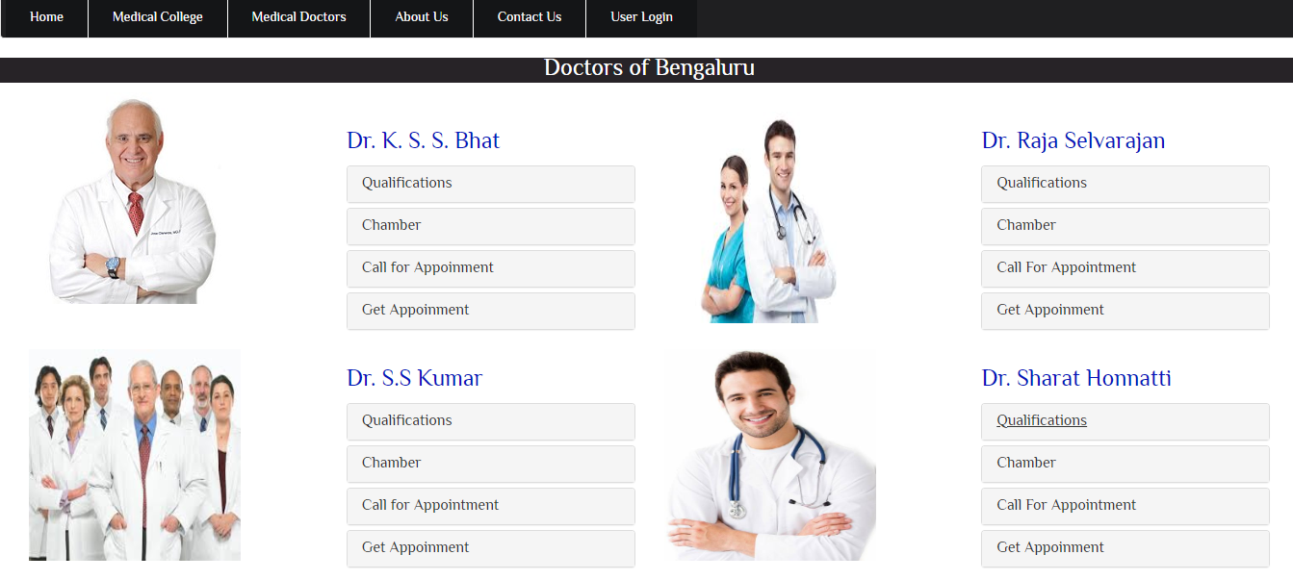

Fig. 6.2: Doctors Details for Doctor Appointment System





Fig. 6.3: User Login for Doctor Appointment System

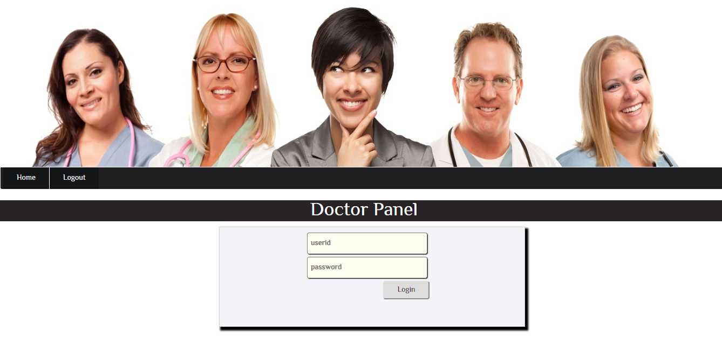

Fig. 6.4: Doctor Panel for Doctor Appointment System



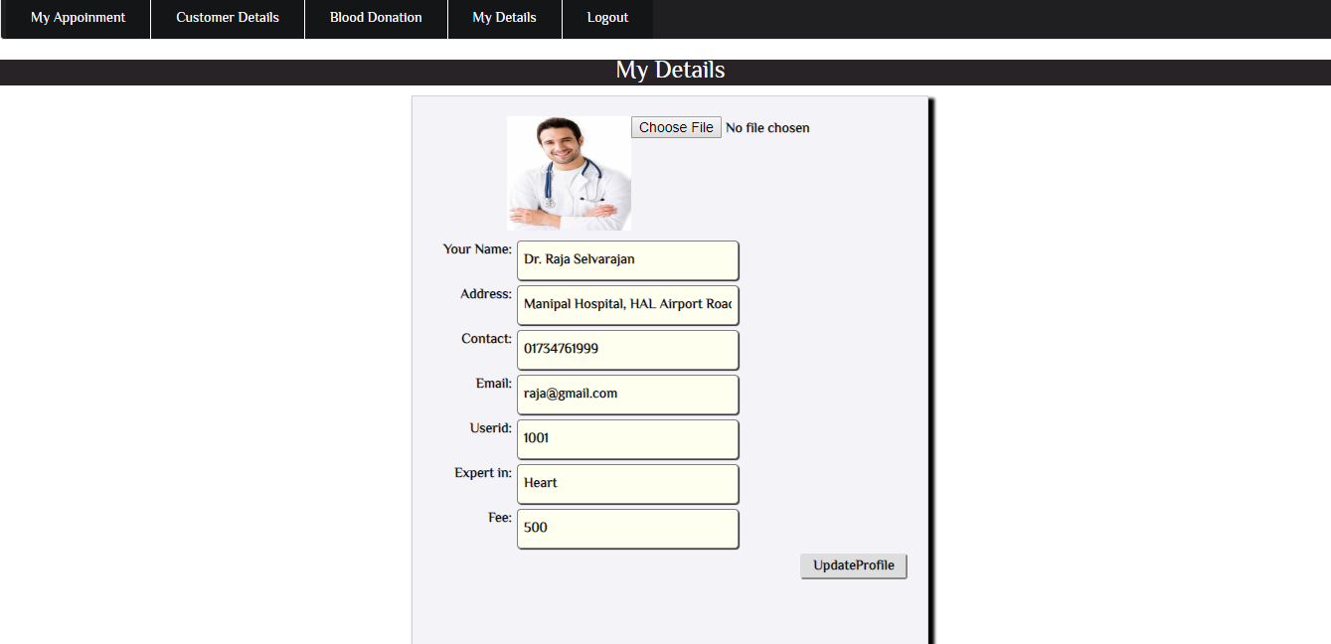

Fig. 6.5: Doctor Profile Details for Doctor Appointment System

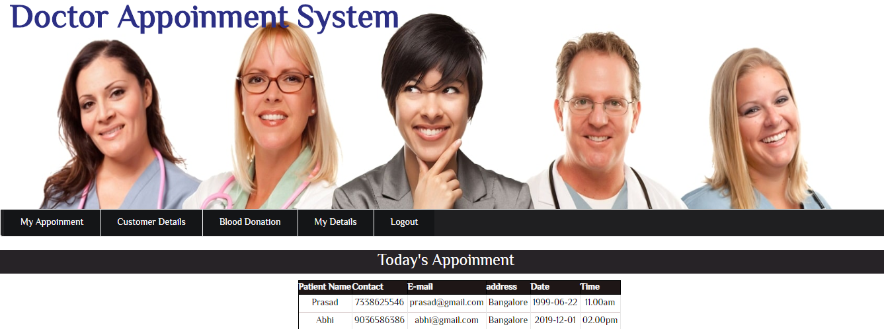

Fig. 6.6: Doctor Appointment Details for Doctor Appointment System

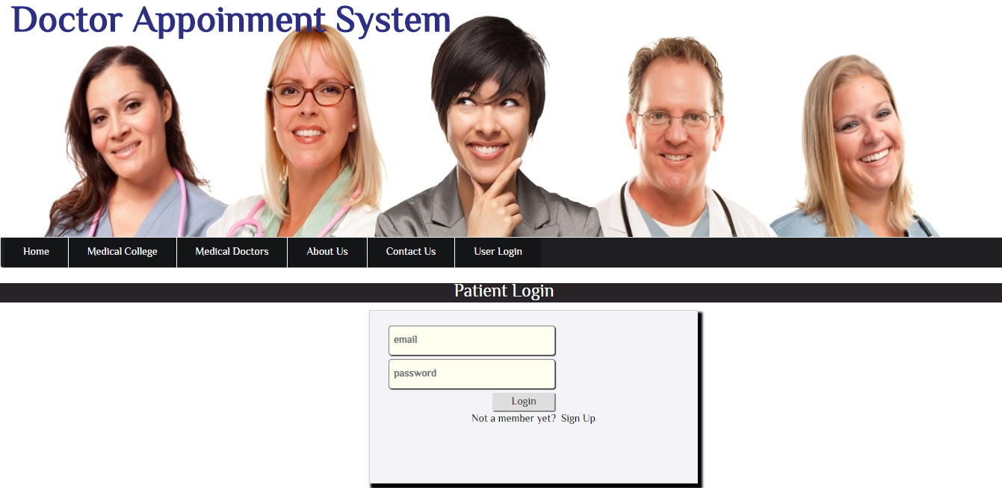

Fig. 6.7: Patient Login Page for Doctor Appointment System



Fig. 6.8: Patient Home Page for Doctor Appointment System



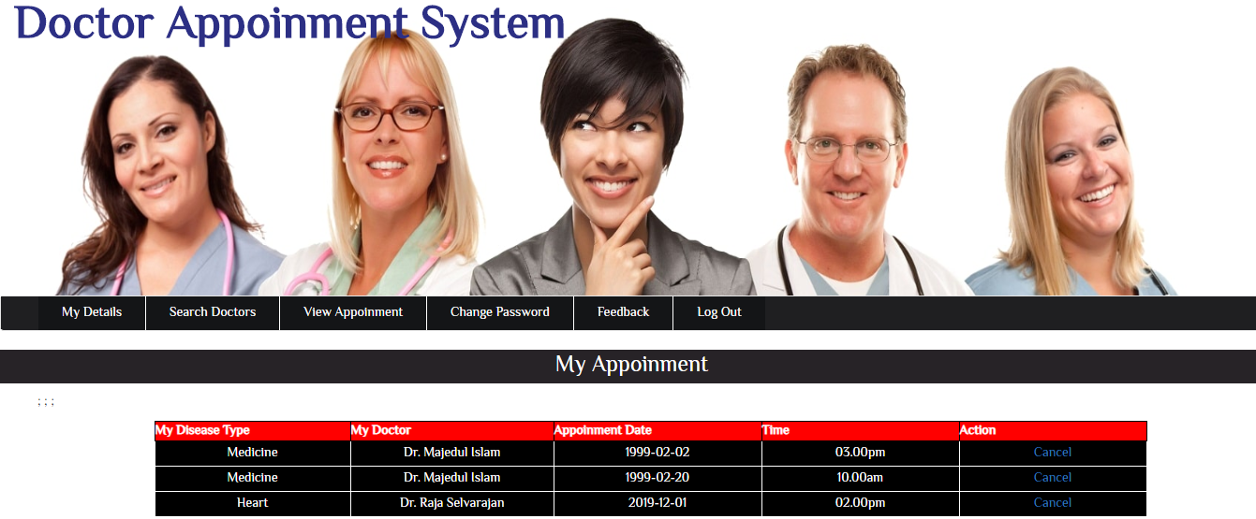

Fig. 6.9: Patient Appointment List for Doctor Appointment System

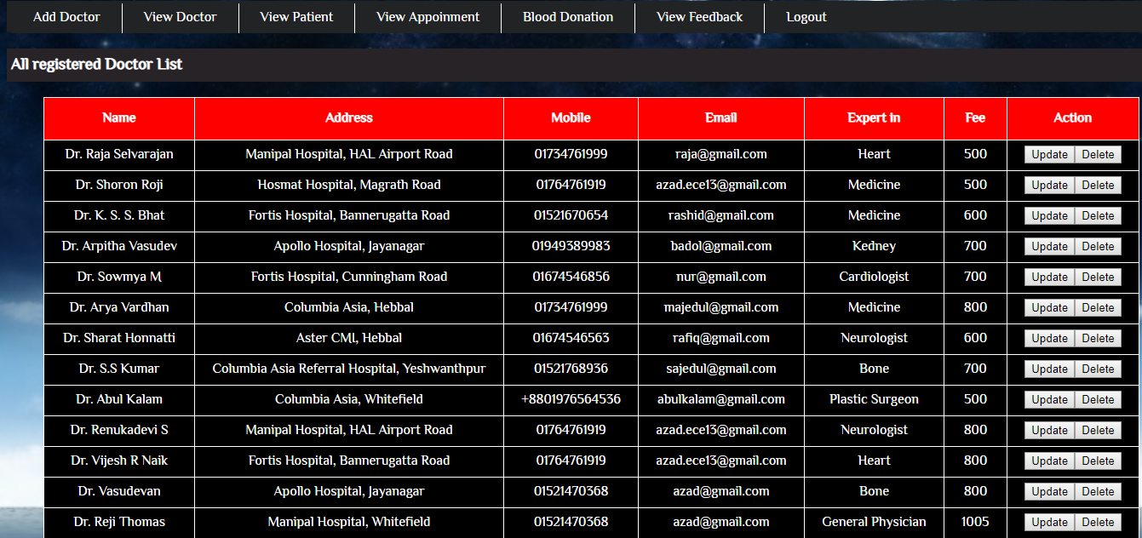

Fig. 7.0: Admin Panel: All registered Doctors List for Doctor Appointment System



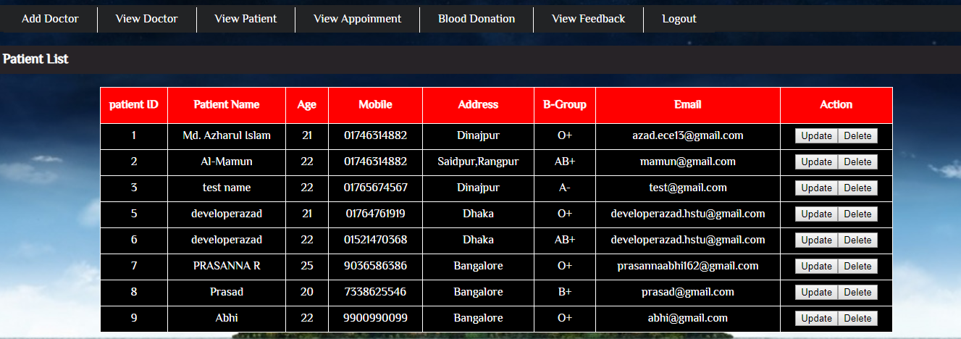

Fig. 7.1: Admin Panel: All registered Patients List for Doctor Appointment System



1. **CONCLUSION**

It has been a great pleasure for me to work on this exciting and challenging project. This project proved good for me as it provided practical knowledge of not only programming in PHP and no some extent Web Application and SQL Server, but also about all handling procedure related with **“DOCTOR APPOINTMENT SYSTEM”**. It also provides knowledge about the latest technology used in developing stand alone application and client server technology that will be great demand in future. This will provide better opportunities and guidance in future in developing projects independently. This project offers user to enter the data through simple and interactive forms. This is very helpful for the client to enter the desired information through so much simplicity. The user is mainly more concerned about the validity of the data, whatever he is entering. There are checks on every stages of any new creation, data entry or updation so that the user cannot enter the invalid data, which can create problems at later date. Sometimes the user finds in the later stages of using project that he needs to update some of the information that he entered earlier. There are options for him by which he can update the records. Moreover there is restriction for his that he cannot change the primary data field. This keeps the validity of the data to longer extent. User is provided the option of monitoring the records he entered earlier. He can see the desired records with the variety of options provided by him. From every part of the project the user is provided with the links through framing so that he can go from one option of the project to other as per the requirement. This is bound to be simple and very friendly as per the user is concerned. That is, we can say that the project is user friendly which is one of the primary concerns of any good project. Data storage and retrieval will become faster and easier to maintain because data is stored in a systematic manner and in a single database





1. **BIBLIOGRAPHY**

**REFERENCE BOOKS:**

1. **Fundamentals of Database Systems, Ramez Elmasri and Shamkant B. Navathe, 7th Edition, 2017, Pearson.**
2. **Database management systems, Ramakrishnan, and Gehrke, 3rd Edition, 2014,McGraw Hill.**
3. **Silberschatz Korth and Sudharshan, Database System Concepts, 6th Edition, Mc- GrawHill, 2013.**
4. **Coronel, Morris, and Rob, Database Principles Fundamentals of Design,**

**Implementation and Management, Cengage Learning 2012.**

**WEB URL’S:**

[http://msdn.microsoft.com](http://msdn.microsoft.com/)

[http://codeproject.com](http://codeproject.com/)

[http://stackoverflow.com](http://stackoverflow.com/)

[http://geeksforgeeks.com](http://geeksforgeeks.com/)

